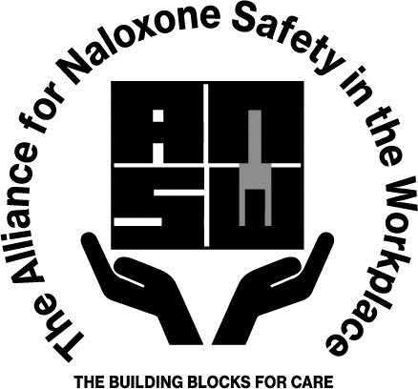
Naloxone Policy Template

Disclaimer: The administration of Naloxone by a layperson during an overdose emergency is protected under Good Samaritan laws in most states. These laws provide legal immunity to individuals who seek emergency medical assistance or administer Naloxone in good faith to someone experiencing an opioid overdose. However, it is important to understand that the use of Naloxone is not a substitute for emergency medical care and individuals who administer Naloxone should still seek professional medical help as soon as possible. Naloxone may only temporarily reverse the effects of an opioid overdose, and additional doses may be required. The administration of Naloxone should be done carefully and in accordance with the instructions provided. If you are unsure of how to administer Naloxone, seek guidance from a healthcare professional or emergency services personnel.

Purpose
It is the intent of (Company Name) to prevent opioid-related deaths on companies’ premises. These established guidelines and regulations will govern the utilization of Naloxone used by (Company staff title) within the organization. The objective is to treat and reduce the injury and fatality from opiate overdoses.

Naloxone is a medication that can reverse an overdose caused by an opioid. When administered during an overdose, naloxone blocks the effects of opioids in order to prevent death. Naloxone is safe to use and has no potential for abuse. It is easy to administer, non-narcotic and non-addicting prescription medication. Naloxone (also known as NARCAN) is packaged with two devices, each providing a 4mg/ 1ml dose.

Policy
(Company Name) will thoroughly train and equip (key staff/any worker(s) performing work on the companies’ premises) so they may administer Naloxone to any person suspected of experiencing an opioid-related overdose. Assure that all (departments/locations) stock Naloxone as an opioid antagonist to treat a case of suspected opioid overdose on companies’ premises. It is the policy of (Company Name) for trained staff to administer in accordance with state law to persons suffering from opioid overdose symptoms at the earliest possible time to minimize chances of a fatality. Any time Naloxone is administered, the Naloxone Report form must be completed and submitted to the ___________ department for review and recordkeeping.

Training
(Company training participants – i.e. all employees, all supervisors, etc.) will receive an initial training that will include an overview of the opioid epidemic; the causes and signs of an overdose and how to use naloxone to save a life. The training will cover what to expect when administering Naloxone, as well as how patients may respond, and appropriate aftercare including the requirement for emergency services after administration. The training will also address Good Samaritan Laws and how to eliminate the risk of an overdose through the use of alternative approaches to pain management. The training will include a brief post- survey to assess knowledge enhancement and verify the effectiveness of the training. It is important to have First Aid/ CPR trained individuals present onsite where Naloxone is provided. These individuals should, wherever feasible, be involved in the administration of Naloxone and the aftercare for affected individuals. Naloxone training will be provided in conjunction with First Aid/ CPR/ AED training and refreshed on the same interval.

The training facilitator will share with the attendees the organization’s current policies and procedures and where the training participants can locate a Naloxone supply for use within their workplace. Continuing education will be offered as a refresher to this topic (bi-annually, annually, etc.).

Procedures
Naloxone will be distributed as Narcan nasal spray in an original, sealed manufacturers box. The box contains two devices each with one dose. The box will contain administration instructions.
The Naloxone Nasal spray will be kept in a zippered bag marked “overdose response kit” and the zipper will be sealed with a tamper evident tie. These overdose response kits will be located _________ (Insert location here, i.e. inside the AED cabinets).
If an employee with training encounters a person who may be suffering from an apparent opioid overdose, that employee shall follow the protocols provided with the AHA training. Here is a summary of the response along with algorithm:
- If the person is responding and breathing, phone 911, get the AED and overdose kit, if available.
- If the person is not responding but breathing, phone 911, tap and shout, reposition and consider giving a dose of Naloxone
- If the person is not responding and not breathing or is only gasping, phone 911, start CPR, give a dose of Naloxone, and use an AED.
- Refer to American Heart Association (AHA) algorithm below:
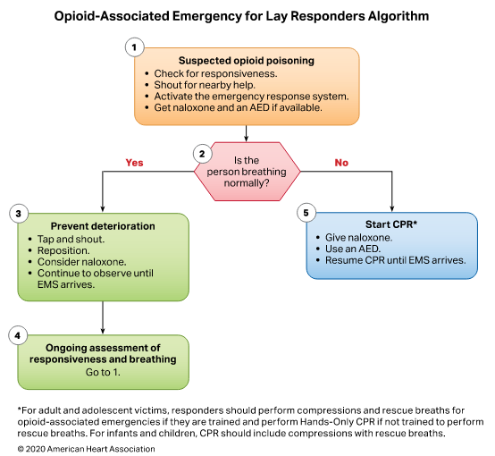

After administering Naloxone, the responding employee will complete the Naloxone use report form (see attached) and provide the form to (insert appropriate report collector here).
In order to ensure safe and effective access to Naloxone, the Corporate Safety Director (customize to your organization) will ensure a proper inspection and replacement schedule that mirrors that of the AED maintenance schedule. Project team (customize to your location) is responsible for weekly checks of the overdose response kits, ensuring they are stored in a climate-controlled environment (do not allow to freeze or store above 104⁰ Fahrenheit) and replacements are on hand in a timely manner should a kit get used or expire.

Attachment A
